From the Mountains to the Estuary:
From the Schoolyard to the Bay

Meaningful Watershed Experiences
for Grade 6 Students

Created by:

 | 
With grant support from
The NOAA Bay Watershed Education Training (B-WET) Program



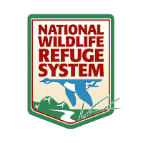
In partnership with:

Occoquan Bay National Wildlife Refuge
Manassas Battlefield National Park

Word Wall Cards for:

6.7 The student will investigate and understand the natural processes and human interactions that affect watershed systems. Key concepts include
- the health of ecosystems and the abiotic factors of a watershed;
- the location and structure of Virginia’s regional watershed systems;
- divides, tributaries, river systems, and river and stream processes;
- wetlands;
- estuaries;
- major conservation, health, and safety issues associated with watersheds; and
- water monitoring and analysis using field equipment including hand-held technology.

Word Walls

A word wall is a group of words that are displayed on a wall, bulletin board, chalkboard, or whiteboard in a classroom. The words are printed in a large font so that they are easily visible from all student seating areas. These words are referred to continually throughout a unit or term by the teacher and students during a variety of activities. A word wall works both as an active learning tool (the student and teacher continually refer to and use the word wall in activities) and a passive learning tool (the student refers to the wall during other learning activities). Add words to the Word Wall as you introduce the target vocabulary. Review the words daily. Change the words as you begin a new lesson. Word Walls lend themselves to a variety of activities.
From Robyn Cole, Woodbridge MS
Here are a few ideas:

Five Clues: Have each student number their paper from one to five. Give a clue about one of the words on the Word Wall. Students should write down the word they think you are thinking of. Keep giving clues (up to five) until everyone has guessed the word you were thinking of.

Lights On!: You’ll need a flashlight for this activity. Turn off the classroom lights. Then point the flashlight at one word on the Word Wall. Call on a student to read the word and either use it in a sentence or provide the definition. When the student is successful, it is his or her turn to point the flashlight at a word and choose another student to read the word.

Word-O: Provide each student with a bingo-type grid with six blank spaces. Tell students to fill in the blanks with words from the Word Wall. Put the corresponding definition cards into a jar. Pull the definition cards from the jar one by one. Read the definition and have students cover the corresponding word on their grid with a marker. When the entire card is covered, Word-o!

Card Games: The word cards can be used in many different card games, some of which are variations of games played with regular playing cards. Here are a few ideas for games using the word cards.

Word Cards:

These cards can be also be used as word cards in teacher-led activities, small group activities, to introduce new vocabulary, and to review vocabulary and concepts. Word cards are helpful to visual, kinesthetic, and aural learners. Word cards provide students with visual cues and constant reinforcement.

Consider printing these out on card stock and making a set of the word cards for each student group (cut out, laminate, keep in zippered bags).

Here are a few active learning strategies you can do with the word cards:

- Introducing the Key Terms: Assess prior knowledge by having the student teams group the terms into “Stuff I Know” and “Stuff I Don’t Know.” Discuss student choices and prior knowledge with the class.

- Connecting the Terms: Have student teams match the term with the associated picture. Have them write on a piece of paper how the term and the picture are related.

- Closed and Open Sorts: Have the student teams sort the terms into categories (how are they related?). You can either provide the categories or allow student teams to select them. They then create a map of their sort on a piece of paper.

- Review the Terms – “Concentration”: Students can try a “concentration” game. Turn over all terms and pictures face down. Each student then takes a turn flipping up two cards – if the picture and term match, the student collects the card and earns a point. If not, they flip the cards back over and move to the next person.

- Review the Terms – “Mystery Word”: This game is for four students, playing in pairs. Prepare a card for each target vocabulary word. Put the cards face down in the middle of the table. The first student of the first pair picks a card and gives a one-word clue to his or her partner that will enable the partner to guess the vocabulary word. If the partner does not guess the word, the word goes to a member of the other pair who gives a hint to his or her partner. The team that successfully guesses the word keeps the card. The team with the most cards wins!

Contour line | A line on a topographic map that connects points of equal elevation.
Chesapeake Bay | The largest estuary in the United States.
Topographic map | A diagram that shows the shape and elevation of the land.

Contour interval | The difference in elevation from one contour line to the next.
Non-point source  Pollution | A widely spread source of pollution such as road runoff, which is difficult to link to a specific origin.
Point source  Pollution | A specific source of pollution that can be identified.

Divide | A ridge of land that separates one watershed from another.
Wetland | An area of land that is covered by a shallow layer of water during some or all of the year.
Erosion | The process by which water, wind, ice, or gravity moves fragments of rock and soil.

Groundwater | Water that fills the cracks and pores in underground soil and rock layers.
Water cycle | The continuous process by which water moves from the earth’s surface to the atmosphere and back.
Water table | The depth from the surface to the groundwater.

Drought | A water shortage caused by periods of low precipitation.
Renewable Resource | A resource that is naturally replaced in a relatively short time.
Conservation | The process of using a resource wisely so it will not be used up.
Macroinvertebrate | An organism without a backbone that is large enough to see with the naked eye.
Concentration | The amount of one substance in a certain volume of another substance.
Watershed | The area of land that supplies water to a river or ocean system.

Runoff | Water that flows over the ground surface rather than soaking into the ground
Estuary | A coastal inlet or bay where freshwater mixes with salty water

pH scale | How acidic or basic a substance is, measured on a scale of 1 (very acidic) to 14 (very basic)
Turbidity | The total amount of sediment stirred up in water…a measure of how clear water is
Salinity | The total amount of dissolved salt in a water sample

Contour line | 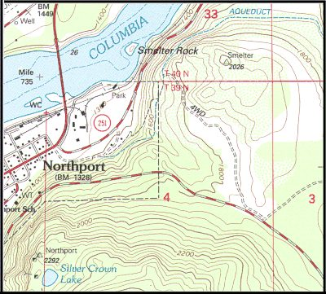
Chesapeake Bay | 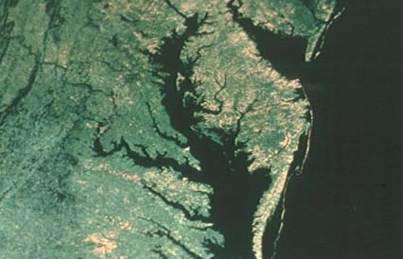
Topographic map | 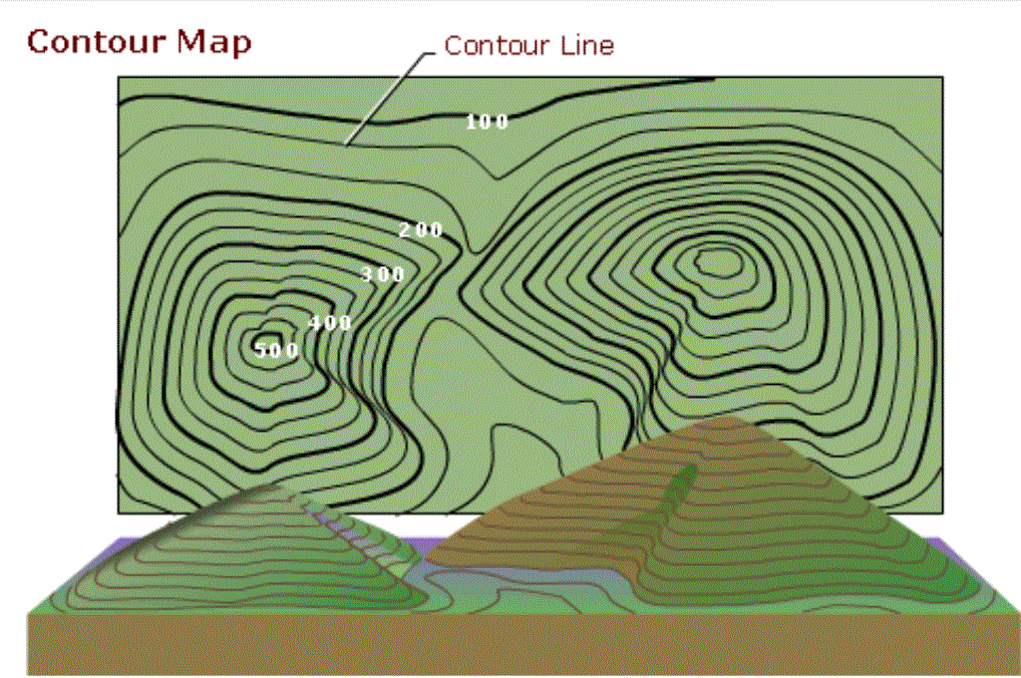

Contour interval | 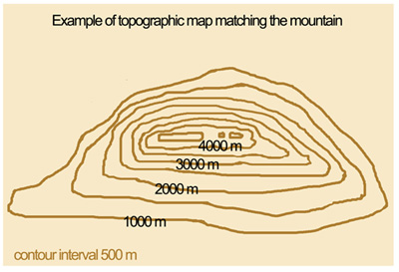
Non-point source  pollution | 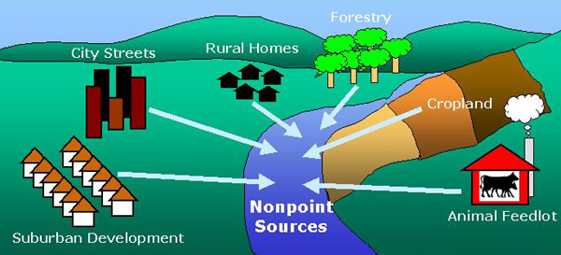
Point source  pollution | 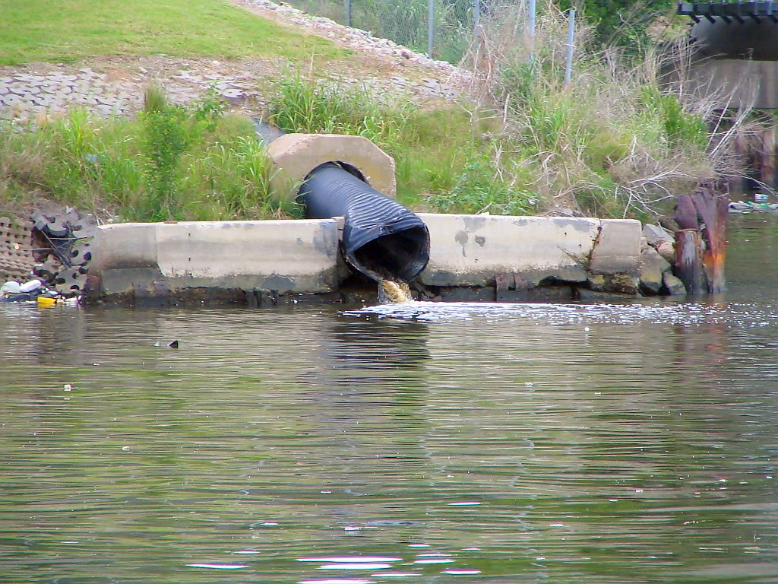

Divide | 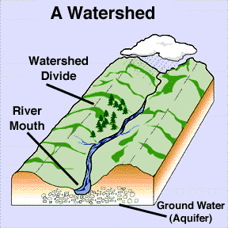
Wetland | 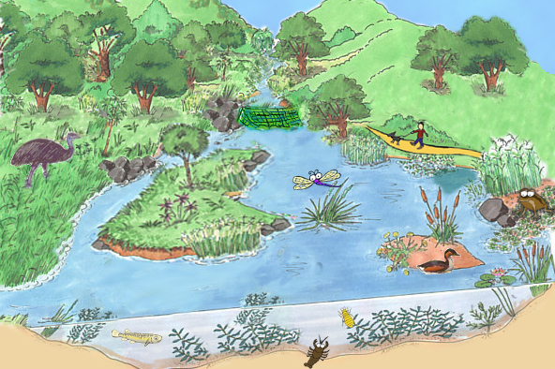
Erosion | 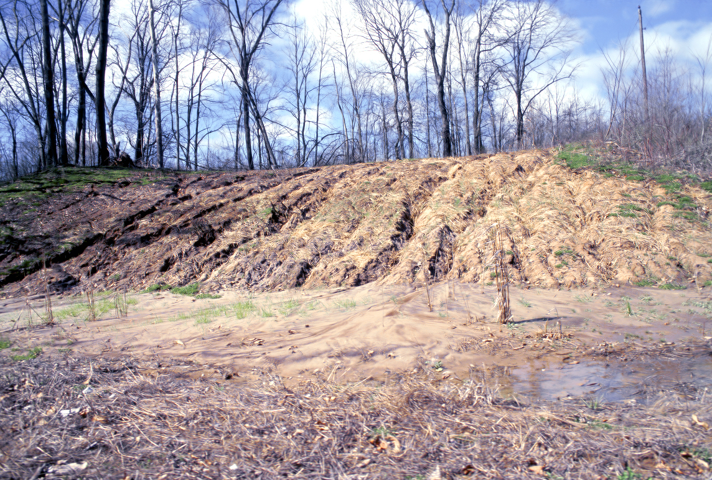

Groundwater | 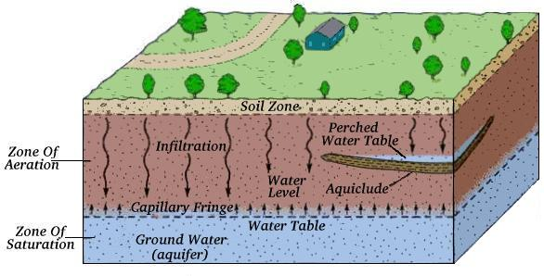
Renewable Resources | 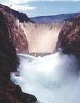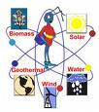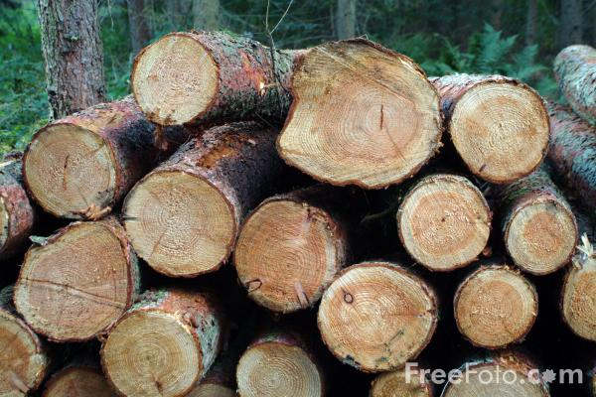
Conservation | 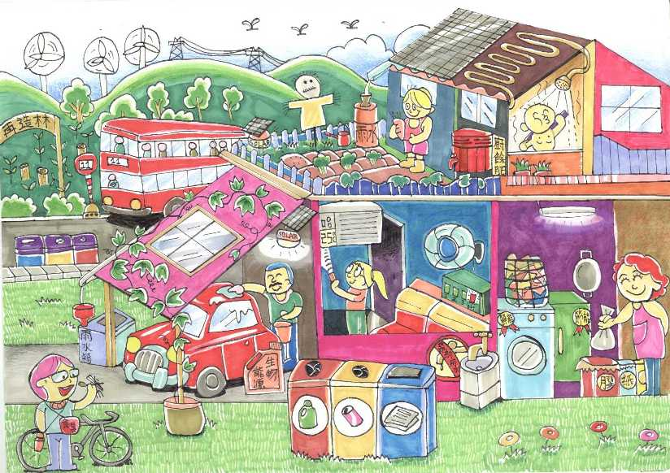

Macroinvertebrate | 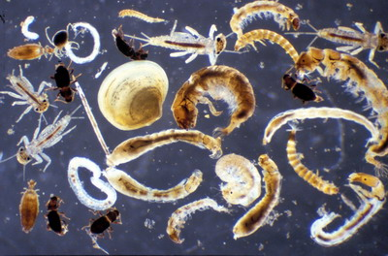
Runoff | 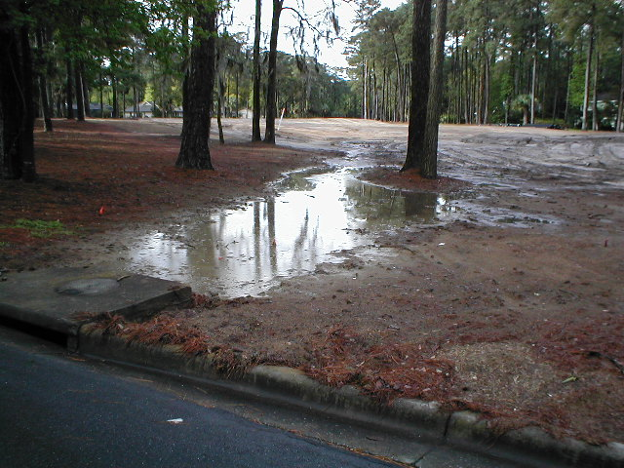
Nonrenewable  Resources | 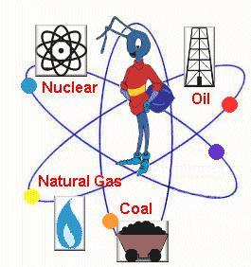

Estuary | 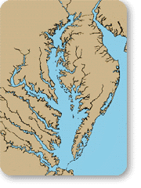
Tributary | 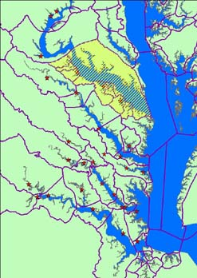
pH scale | 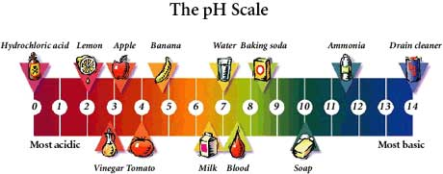

Salinity | 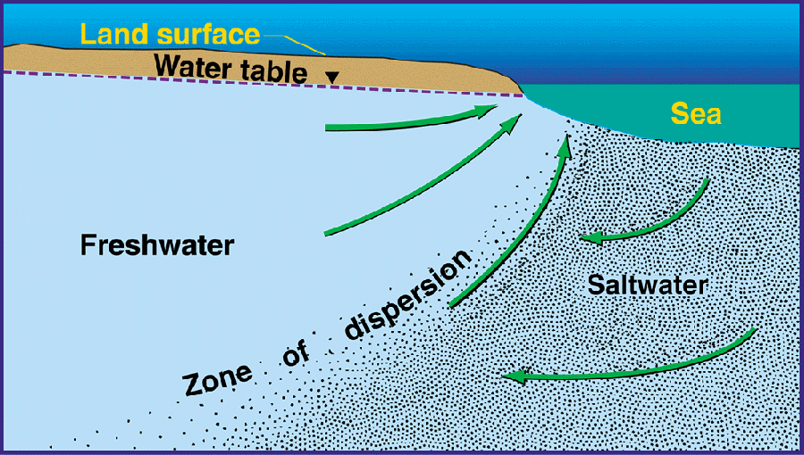
Drought | 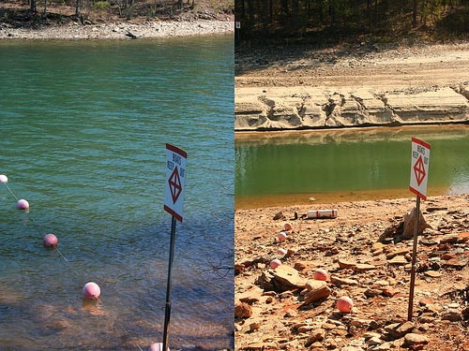
Watershed | 

