From the Mountains to the Estuary:
From the Schoolyard to the Bay

Meaningful Watershed Experiences
for Grade 6 Students

Created by:

 | 
With grant support from
The NOAA Bay Watershed Education Training (B-WET) Program




In partnership with:

Occoquan Bay National Wildlife Refuge
Manassas Battlefield National Park

Watershed Address Using Google Maps
Integrating Technology
Connecting to the Chesapeake Bay

Overview

Students will view their school and identify their watershed while navigating through satellite images, topographic, and terrain maps.

Materials
- Computer with web browser, able to access to the Internet and Google Maps
- Composition Notebook for each student
- [For optional extensions:] teachers need -
  - A free gmail.com account to store their own map (extension activity 1)
  - A digital camera to upload schoolyard images (extension activity 2)

Setting the Stage

Have the students imagine for a moment that they are a raindrop. If you fell out of the sky right near the school, which body of water would you end up in? Do you know the path that you would take to get there? Let’s see if we can find out those answers using Google maps.

Acquisition of Learning

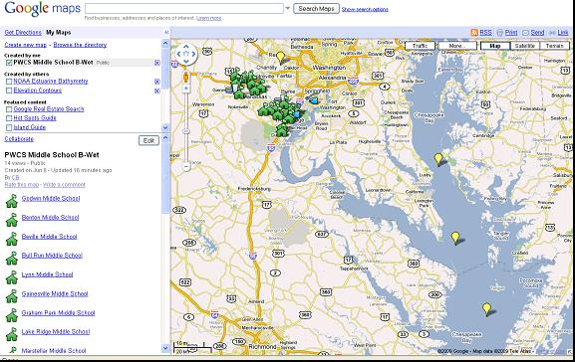
- On the Internet, go to Google Maps via http://tinyurl.com/pwcs-bwet. After a few moments, a map of the Chesapeake Bay and PWCS middles schools will appear. (It may take a minute or two to load). To the left of the map is a “legend,” or key to understanding the symbols on the map. (A green schoolhouse icon represents each middle school in Prince William County.)
Zoom out

- Click on your school’s name from the list in the legend. Clicking there will re-center the map on your school. If you do not see your school, scroll down to the bottom of the page and go to page 2.

- To zoom in using the vertical slider bar under the Little Yellow Man, click on the + sign. To re-center the map, hold down the left mouse button and drag the schools into the center. Click on a few schools (green map icons or on names on left panel) to see what pops up. When done, click Zoom Here at your school. Zoom back out by clicking on the – sign at the bottom of the slider bar.

- Have students investigate the map. To see locations for 6th Grade Field Trips and where GMU collects their water quality data: Click on each location below and then zoom back out. Click on the Hikers at the Manassas Battlefield. Zoom back out and Click on the Fish at the Occoquan Bay Refuge in Woodbridge. Using the hand tool you can move towards the right and north of the refuge and find the PEREC flag in Belmont Bay Marina to access PEREC real-time water quality data from the probe attached to the dock.

- Click on and drag the Little Yellow Man in the upper left corner around the map to different schools. If a street image is available it will show up when you drop him. Click “x” in square in the upper right of the image to close the street image map.

- Referencing the scale lines at the bottom left corner of the map, click on the Zoom Slider in the upper left corner and Zoom out until the map is at the 10 mi/20 km scale and you can see the three yellow ‘lightbulbs’ in the Bay. Then click on Satellite in the upper right corner. You should see the image below. Center on the Potomac River, which leads from the pack of PW County school icons into the left side of the Chesapeake Bay.

- Find the Chesapeake Bay. The vertical string of yellow markers in the Bay link to different sources of water quality data: NOAA’s CBIBS buoys, SAV re-vegetation projects and water quality parameters by month. Click on them.

- Locate and identify major Bay tributaries. Click on Terrain in the upper right corner to see the names of the rivers that empty into the Bay. You can also see the topo lines indicating slope.

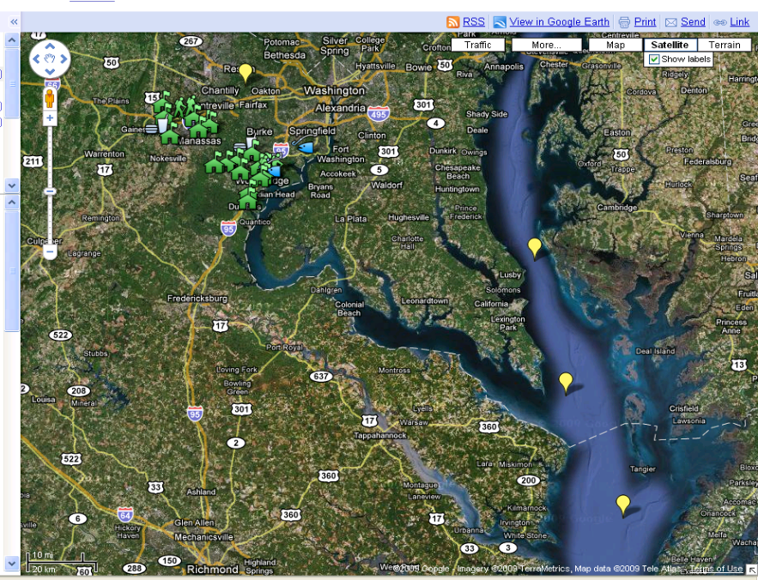
- Follow the Potomac River away from the Bay towards your school. Have the students record your school’s watershed address in their composition book, i.e. the path of surface waters a raindrop might take, beginning with your school yard and ending at the Atlantic Ocean. You may want to flip between Satellite image and Terrain Maps to see the water body names and slopes.

School Name: _____________________________, closest creek________________________,
next larger creek or river ___________________ etc…

- On the satellite image, Find Leesylvania State Park, (find Rippon Middle School or Porter Traditional School in the school list, click on either link and zoom in until you see Leesylvania State Park - about 2 mi South of Rippon Middle School on the Potomac). At the very tip in the Potomac River, find the park’s fishing pier. Click on More in the white bar above and then click box by Photos to see an image of the fishing pier. If you can’t see the photo, zoom out until it’s visible. In what state is the pier located __________________?

- Neabsco Creek lies to the north and Powell’s Creek to the south of Leesylvania State Park. What do you notice about the depth of these creeks compared to the Potomac River depth?
How may have this condition occurred?

- How do Powell’s and Neabsco Creek compare to Quantico Creek? (Hint: Look at the land use upstream)

In 1763 Dumfries was the 2nd leading port in colonial America for tobacco transport. What changed? http://www.dumfriesvirginia.org/history.html http://www.fergusonfoundation.org/btw/watershed_timeline/timeline_frameset.html

Closure:
Check student understanding by reviewing watershed address. Have the students once again imagine they are raindrops and that they follow this path on their way to the Chesapeake Bay.

Extension Activity 1: How Far from Here to the Bay?

If you want to find out distances between places, or perimeter of buildings/structures or the distance a rain drop travels from your school to the Bay; in Edit mode, click on the Line Tool and drag it to your beginning point and click. Click again where you wish to stop measuring (i.e. a bend in a stream). Keep clicking and the distance traveled increases. You can name and save this line to your map using the procedure below.

Extension Activity 2: Creating your Own Schoolyard Map

- Take your students outside with a digital camera to conduct a schoolyard investigation.
- Have them take photos of various landmarks including the highest point, the lowest elevation, storm drains, areas of erosion, and other points of interest that might influence the water flow.
- Back in the classroom upload your photos to your school fusion class page.
- Open your gmail account
- Go to Google maps: http://maps.google.com/ Click on My Maps
- Click on: Create New Map then Type in your school address and click search
- Find your school and zoom in on it so you have the full school yard centered on screen.
- Click on Add a Placemark (the blue bubble) in the top left corner. Drag the Placemark to the highest point on your schoolyard and drop it.
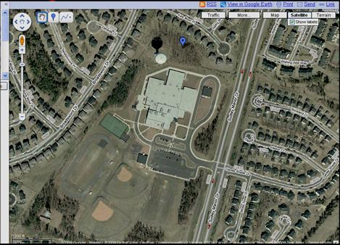
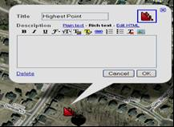
- A little conversation box will pop up. Click on the icon, scroll down and choose the Red Falling Rocks. Type Highest Point into the Title text box.

- Description: click on Rich Text. Then click on the little blue picture on the right below the words edit HTML. A dialog box will pop up and ask you to enter the URL to an image. In a separate browser window, find the image that you posted on your school website. Right click over the image, a dialog box pops up. Select Copy Image Location.

- Go to your maps and click on the little photo icon and a dialog box will pop up. Highlight/Copy/Paste the image location address of the web photo you wish to use into the URL text box. Click Ok.

- Type in a descriptive few words about your image...like elevation 100ft., or Cindy pours water from ridge top, Stormwater runs downhill from here, etc.. Play with font colors/format if desired. Click Ok and close box.

- In the left side panel type in the Title of your map using your middle school’s name.

- Click Save.

- Repeat steps 8 – 14 to add in your lowest point, storm drains (number drains) downspouts to complete your map. Click Save after every new change. If you want this map available for others to see, click Public.

- Click Save after any changes and Done when finished.

- You must be logged into Gmail to open and EDIT the Google map.


