From the Mountains to the Estuary:
From the Schoolyard to the Bay

Meaningful Watershed Experiences
for Grade 6 Students

Created by:

 | 
With grant support from
The NOAA Bay Watershed Education Training (B-WET) Program




In partnership with:

Occoquan Bay National Wildlife Refuge
Manassas Battlefield National Park

Discovering the Water Quality Of Belmont Bay
Local Data in the Classroom

Overview

Students use real-time scientific data to explore dynamic processes in Belmont Bay in Woodbridge, VA. How is water quality monitoring done and what does the data mean? Students will access and interpret water quality data, and look for patterns and changes over time.

Materials Needed

Computer with internet access.
Belmont parameter sheets
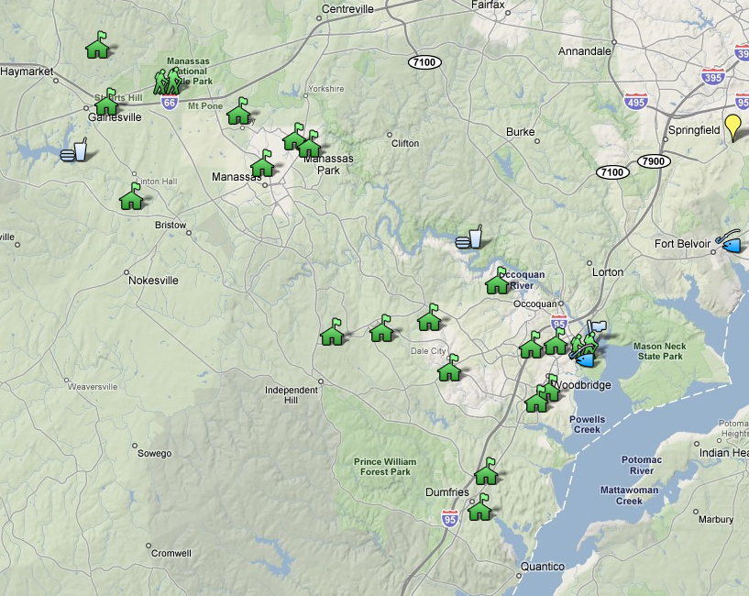
Data sheets http://perec.gmu.edu
Occoquan River

Setting the Stage

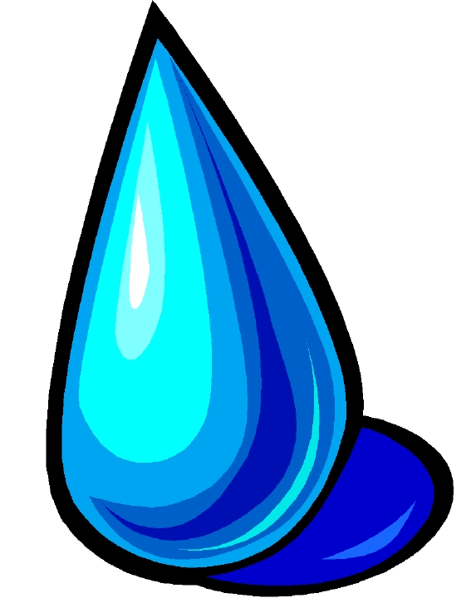
What drips, drops or spills in your schoolyard can be washed all the way to the Bay during storm events. Stormwater from Prince William County Middle Schools drains into retention ponds or small streams. These flow into larger streams, many of which flow into the Occoquan River. The Occoquan River flows into Belmont Bay which drains into the Potomac River and ultimately into the Chesapeake Bay.

You can track the path a water droplet from your school and see what changes in water quality occur as the droplet flows into Belmont Bay.

Acquisition of Learning

This activity is best done after completing the Watershed Address Using Google Maps and the NOAA Data in the Classsroom activity.

- To provide students with a point of reference in the classroom on screen, first show them of map identifying where their school is located, the Occoquan River and Belmont Bay in Woodbridge. You can use the PWCS Middle School B-wet google map or any other map.

- A data logger or sonde is attached to the end of the dock at the Belmont Bay marina can be accessed by going to this website http://www.ysieconet.com/public/WebUI/Default.aspx?hidCustomerID=195 or by using the PWCS Middle School B-wet Google map: Click on the flag in Belmont Bay on the dock. Then click on the link to Belmont Bay water quality data here.

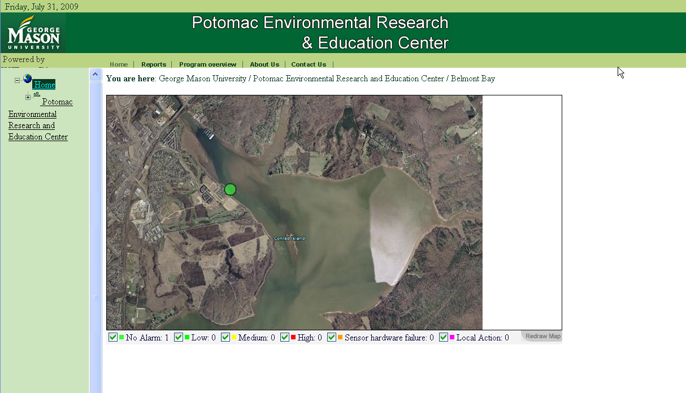
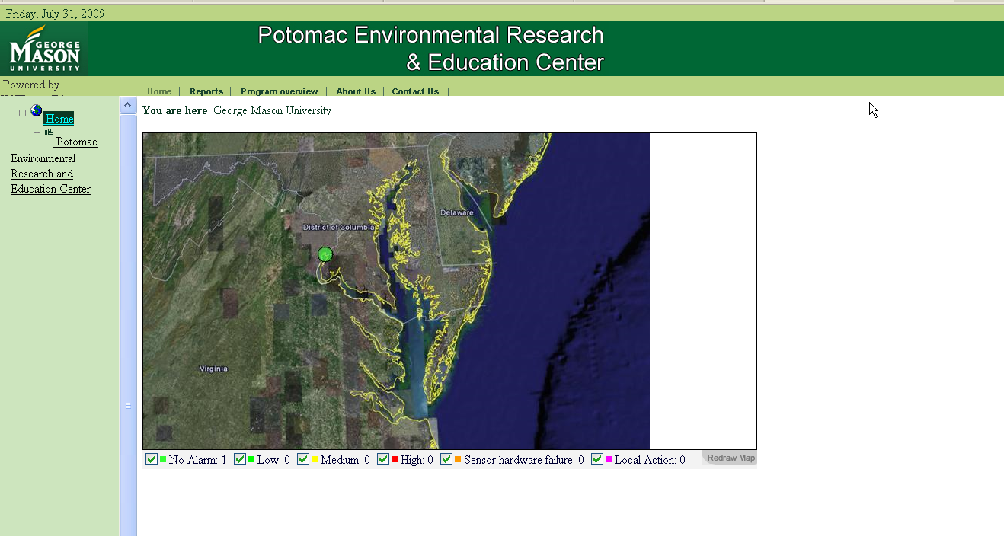

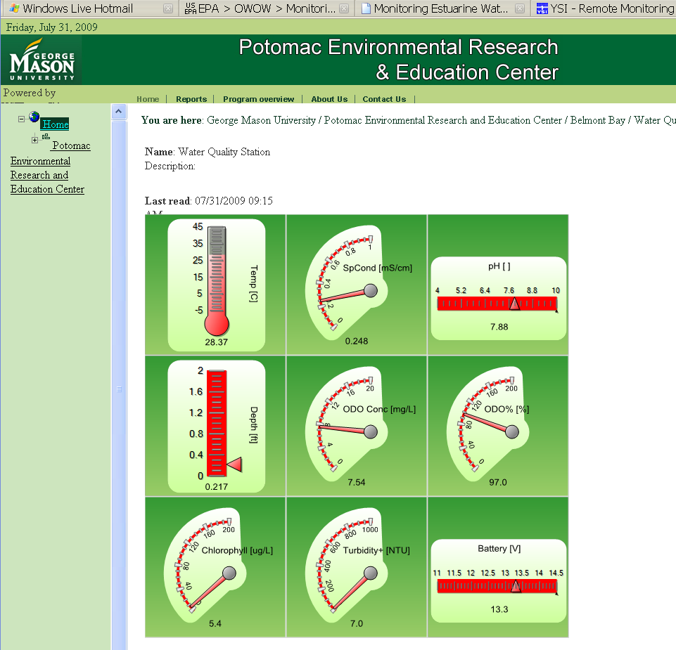

- Click on the green dot THREE times until the screen with the nine gauges shows up.

- Each student or groups should look at their Belmont Bay Water Quality Parameter sheet. While you have the gauges up on screen, ask the students how the data is collected. using a data logger attached to the dock. The image is on the Parameter Sheet. How often is the data collected? every 15 minutes. The time is shown on left just above the gauges.

- Explain that eight different parameters are measured every 15 minutes and the ninth gauge shows how much charge is left on the battery. Click on the battery. A screen the a table of readings and a graph shows up. Change the Start Date to two days earlier than the End Date. Click Submit. Examine the graph. What are the units on the Y-axis? Volts. We know this because its written in parentheses (V) next to the name of the parameter. Remind students that they should never created a graph where units are not visible. X-axis units? Day/time. Ask when the battery is most charged, least charge? Why does it fluctuate? Because it is solar powered, no sun at night and charge decreases. Play the the start and end dates to see trends. Why are some days higher than others? Cloud cover, rain fall…Scientists like to have a long term record oftheir data so they can go back and review it.

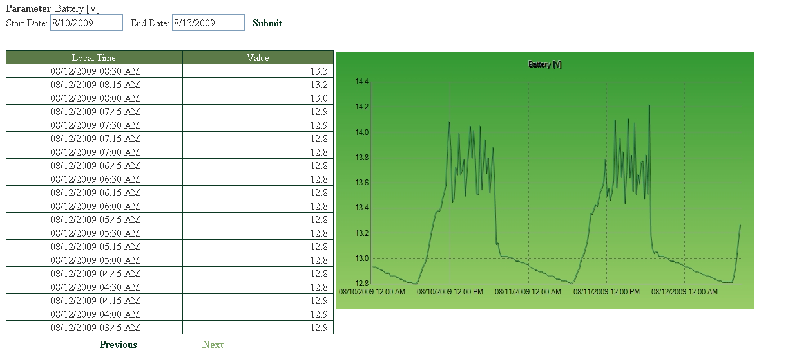

- If at any time the screen goes blank, this means that the water is being sampled again and new data will populate the gauges. Click the blue curved arrow refresh button and click through the screens until you see the nine gauges. To access a different gauge, click on the Green Back arrow to go back to the gauges screen.

- Click on Temperature. Follow the steps above with the graph looking at the axes. Look at data for a 24 hour period. How much does the water temperature fluctuate? Is it higher during the day or night? What is the coldest/warmest month in Belmont Bay? Can we tell if the Bay ever froze over? How does temperature affect dissolved oxygen? Warmer water has less DO.

- Click on the Green Back arrow to go back to the gauges screen. Click on Turbidity. Look at data for a week including the axes. Notice how the units change when you select a longer time span? Why? Shorten your time span. Can students discover why the units change? When do you see spikes in the data? Why? Rain storms wash sediment into streams which increase turbidity downstream.

- Click on the Green Back arrow to go back to the gauges screen. Select your next parameter. Using the Parameter Sheet, develop questions for students to discover about each parameters.

- Assign a different parameter to student groups and have them present their findings to the class. They can include what type of water they are researching, fresh, salt, and estuarine; how plants, animals and invertebrates are affected and human influence on the parameter.

Closure

Any time you have a rain storm at your school, it’s a great time to check on the Belmont data logger and check how Turbidity changes over time as more sediment and other pollutants wash from schoolyards, businesses, roads and construction areas into local streams and on to Belmont Bay.

How does sediment affect the ecosystem?
It clouds the water prevent light from reaching aquatic plants near the shore. They don’t grow well and thus the hiding places for small fish, crabs and other invertebrates just aren’t available.

